CMR INSTITUTE OF TECHNOLOGY, BENGALURU
132, AECS LAYOUT, IT PARK ROAD, BENGALURU – 560037
www.cmrit.ac.in

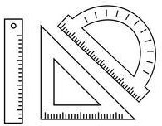DEPARTMENT OF MECHANICAL ENGINEERING

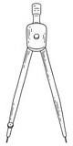

COMPUTER AIDED ENGINEERING DRAWING

22CED13/23
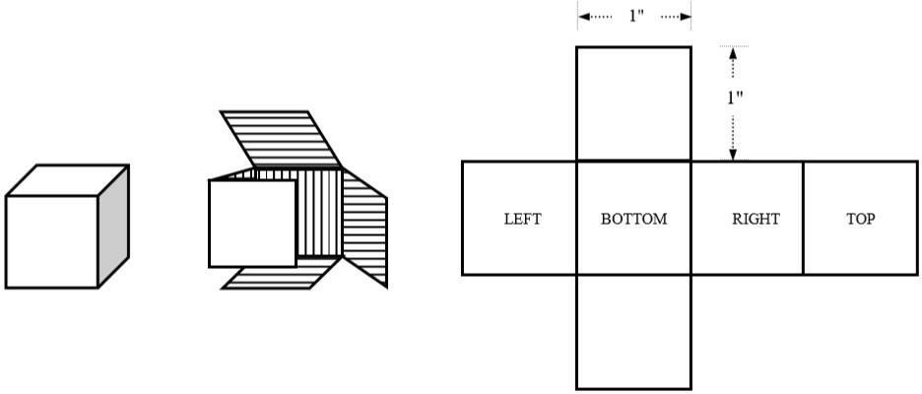
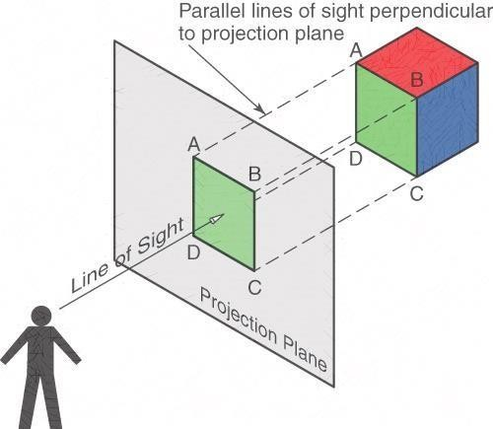
SOLUTIONS

DRAWING NO. 1

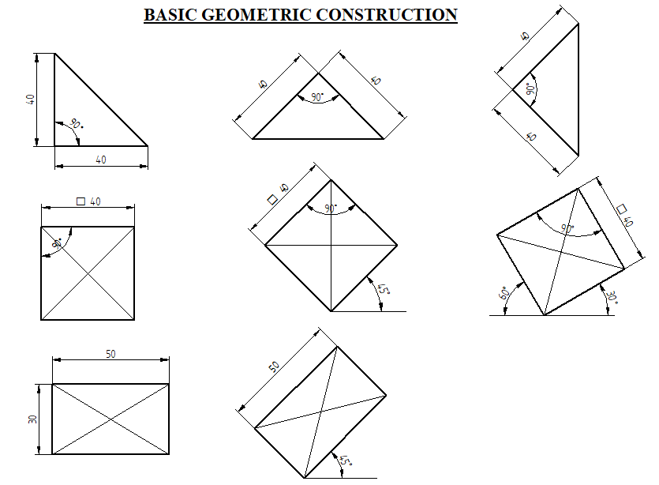

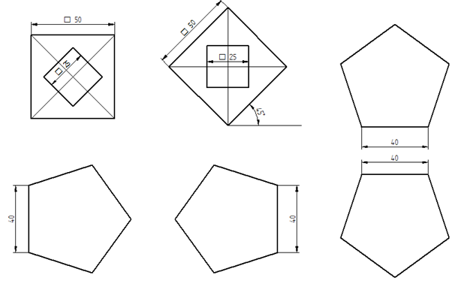
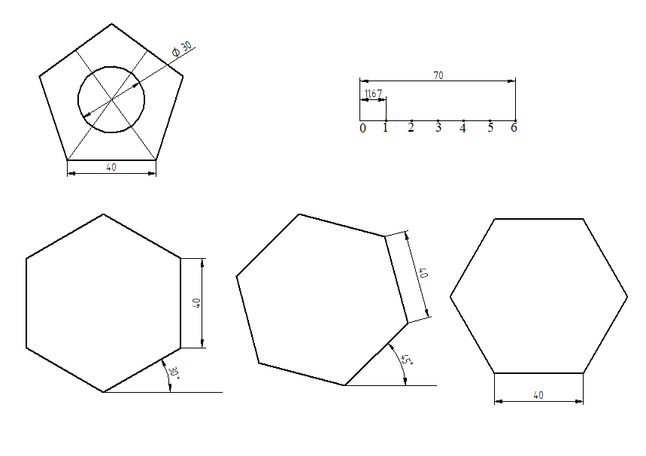

DRAWING NO. 2
PROJECTION OF POINTS:

1/D2. Draw the projections of the following points on the same XY line and state in which quadrants they lie in.
- A is 20 mm in front of VP and 30mm above HP.
- B is 30 mm in front of VP and in HP.
- C is 40 mm behind VP and 20 mm below HP.
- D is 30 mm behind VP and 10mm above HP
- E is 40mm in front of VP and 30 mm below HP.

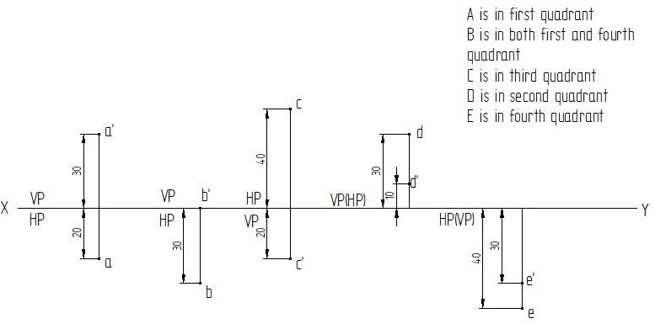

2/D2. Draw the three principal views of a point P lying 65 mm above HP, 70 mm in front of VP and 50 mm in front of the right plane.
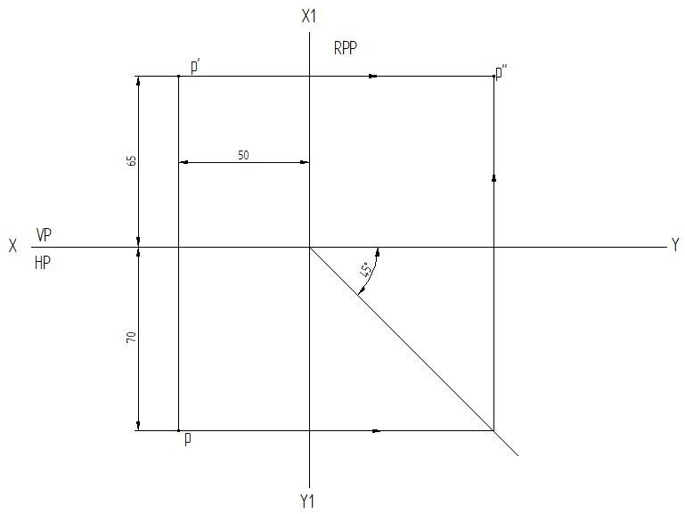

3/D2. Two points A and B are in HP. The point A is 30 mm in front of VP, while B is behind VP. The distance between their projectors is 75 mm and the line joining their top views makes an angle of 45° with XY. Find the distance of point B from the VP.

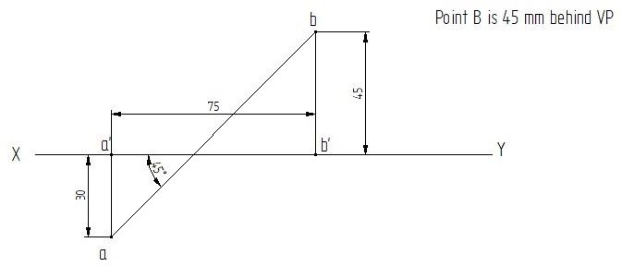

DRAWING NO. 3 PROJECTION OF STRAIGHT LINES:
1/D3. A line AB, 50 mm long has its end A in both HP and VP. It is inclined at 30° to HP and 45° to VP. Draw its projections.
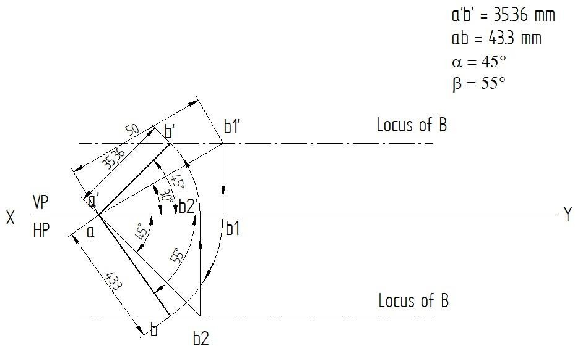

2/D3. A line AB, 65 mm long, has its end A 20 mm above HP and 25 mm in front of VP. The end B is 40 mm above HP and 65 mm in front of VP. Draw the projections of AB and show its inclinations with HP and VP.
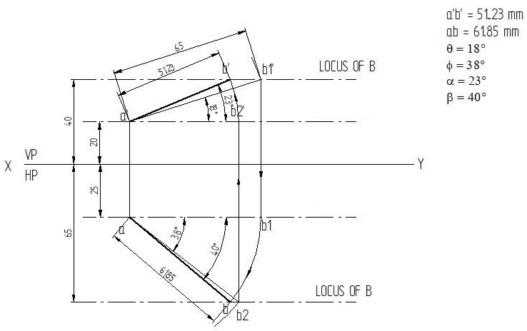

3/D3. A room is 5m x 3m x 4m high. An electric lamp is suspended vertically from the center of the ceiling at a distance of 0.8 m from it. Find the distance of the lamp from any one of the ground corners and the slope angle of the connecting line with the ground.
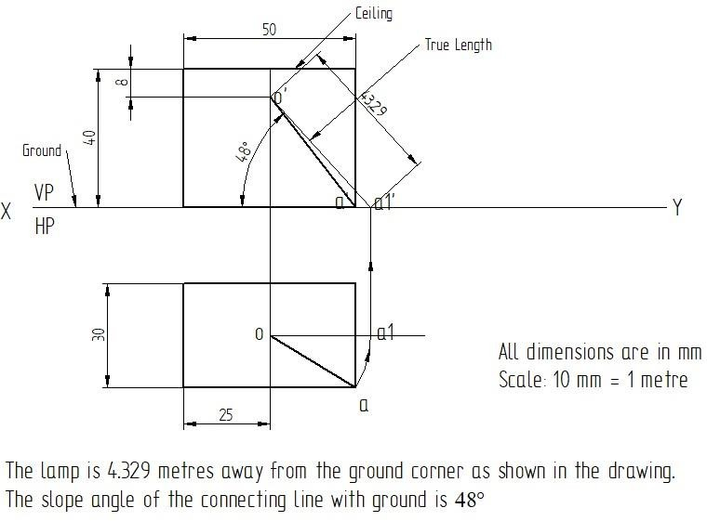

DRAWING NO. 4
PROJECTION OF PLANES

SP1:
1/D4. An equilateral triangular lamina of 30mm sides lies with one of its edges on HP such that the surface of the lamina is inclined to HP at 60°. The edge on which it rests is inclined to VP at 60°. Draw the projections.

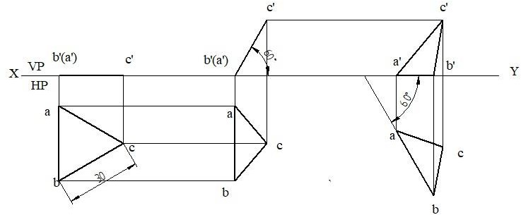

2/D4. A rectangular lamina of sides 40 mm x 60 mm on HP appears as a square in the top view. The 40 mm edges are parallel to both HP and VP. Draw its projection in this position and find its inclination with VP and HP.

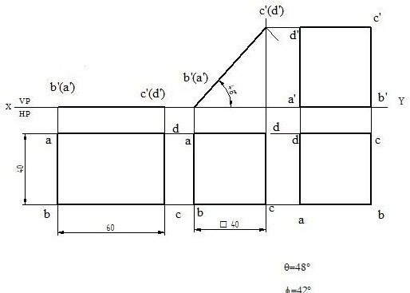

3/D4. A pentagonal lamina of sides 30 mm is having a side both on HP and VP. The surface of the lamina is inclined at an angle of 60° to HP. Draw top and front views of the lamina.
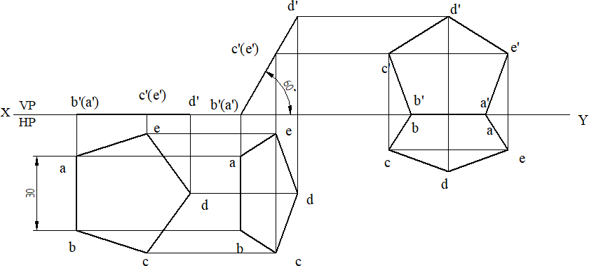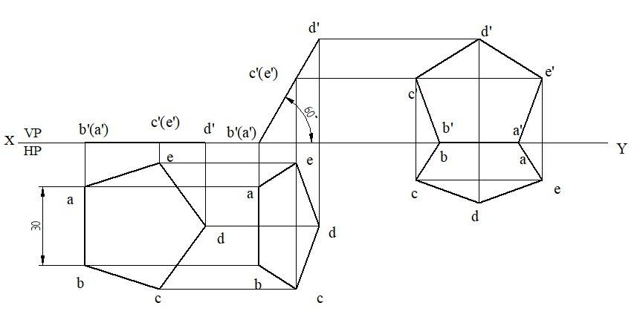
DRAWING NO. 5

SP2:
1/D5. A square plate of 40 mm sides rests on HP such that one of the diagonals is inclined at 30° to HP and 45° to VP. Draw its projections.

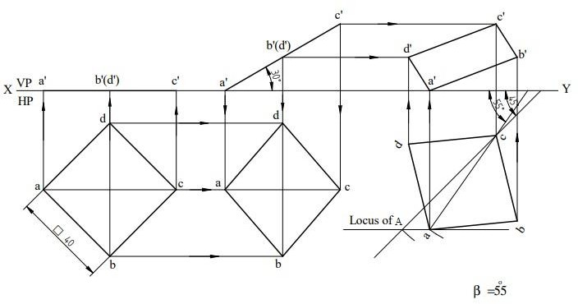

2/D5. A regular hexagonal lamina of sides 30 mm rests on HP such that the diagonal line passing through the resting corner appears to be inclined at 45° to VP and the surface makes an angle of 30° to HP. Draw its projections.

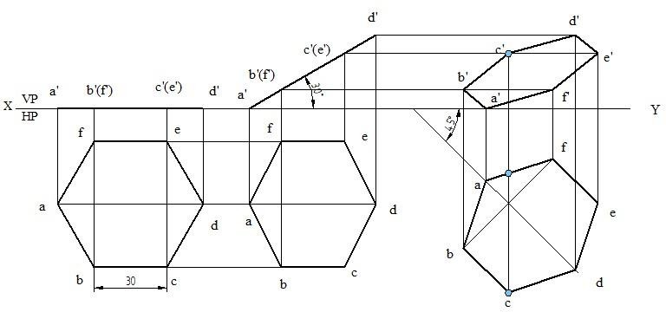
3/D5. A circular lamina of 60 mm diameter is standing with one of its points on the rim on HP and the lamina is inclined at 45° to HP. The diameter at right angles to the diameter passing through the point on which the lamina rests is parallel to VP. Draw the projections.

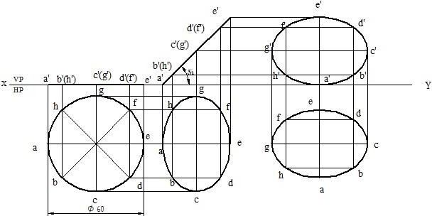

DRAWING NO. 6

SP3:
1/D6. A regular hexagonal lamina ABCDEF of sides 30 mm is lying in such a way that one of its edges touches both the reference planes. If the lamina makes 60° with VP, draw the projections of the lamina.
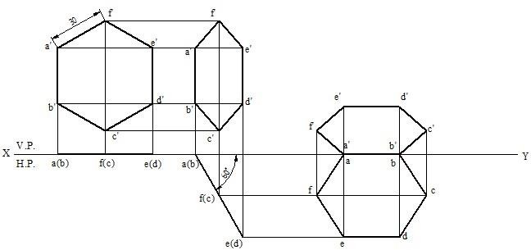

2/D6. An isosceles triangular plate has a base 50 mm long and altitude 70 mm. It is so placed that in the front view it is seen as an equilateral triangle of 50 mm sides with one of its sides inclined at 45° to the XY line. Draw its top and front views.
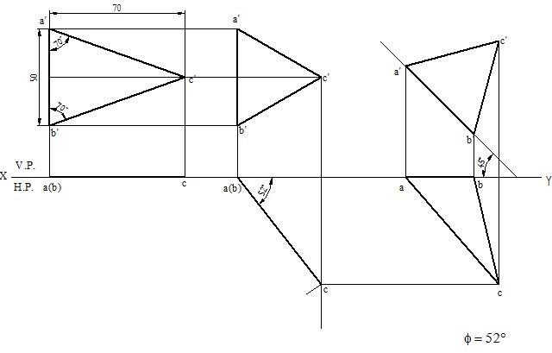

3/D6. A pentagonal lamina having edges 30 mm is placed on VP such that the perpendicular bisector of one of the edges is inclined at 30° to VP and 45° to HP. Draw the top and front views of the lamina.
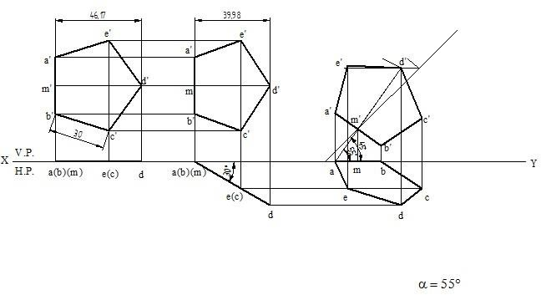

DRAWING NO. 7

SP4:
1/D7. A circular lamina inclined to VP appears in the front view as an ellipse of
major axis 30mm and minor axis 15mm. The major axis is parallel to both H P and VP. One end of the minor axis is in both the HP and VP. Draw the projections of the lamina and determine the inclination of the lamina with the VP.

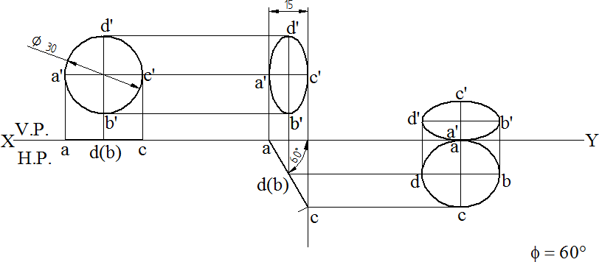

2/D7. A pentagonal lamina of edges 30 mm is resting on VP with one of its corners such that the surface makes an angle of 60° with VP. The edge opposite to the resting corner is inclined at 45° to HP. Draw its projections.

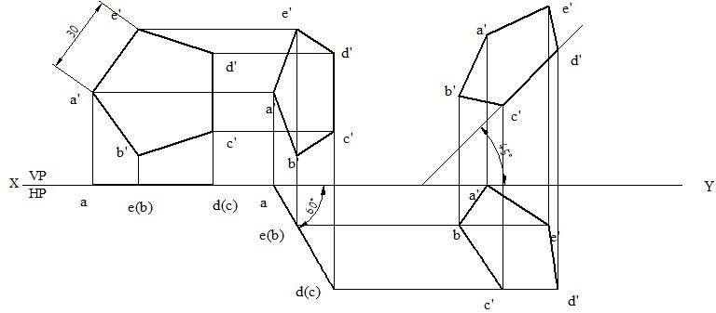

3/D7.A hexagonal lamina of sides 30mm is resting with one of its corners in VP and its surface inclined at an angle of 30° with VP. The diagonal passing through that corner which is in VP is inclined at 45° to HP. Draw the projections of the lamina.

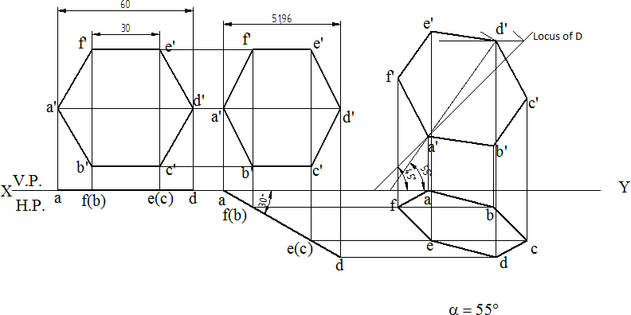

PRISMS:
DRAWING NO. 8

PROJECTION OF SOLIDS

1/D8. A square prism of base 40 mm side and height 65 mm, has its axis inclined at 45°to HP and has an edge of its base on HP and inclined at 30° to VP. Draw its projections.
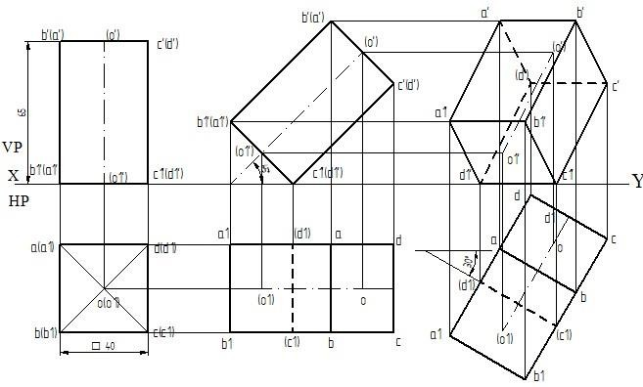
2/D8. Draw the top and front view of a hexagonal prism of sides of base 25mm and height 55mm rests on one of its corners of the base on HP such that the axis is inclined at 45° to HP and appears to be inclined at 30° to VP.
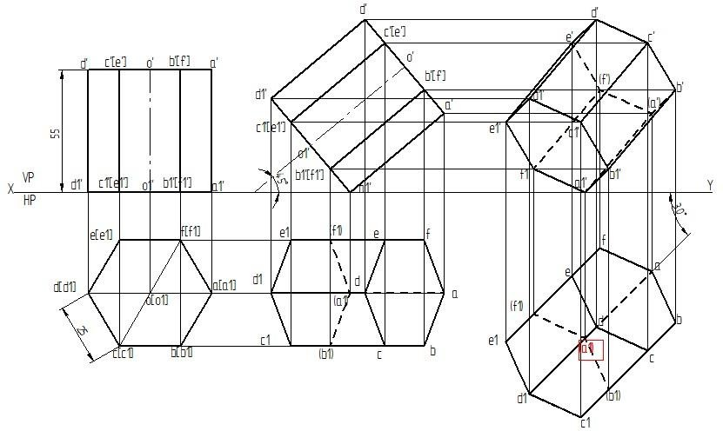

DRAWING NO. 9
PYRAMIDS:
1/D9. A pentagonal pyramid 25mm sides of base and 50mm axis length rests on HP on one of its slant triangular faces. Draw the projections of the pyramid when the axis appears to be inclined to VP at 45º.
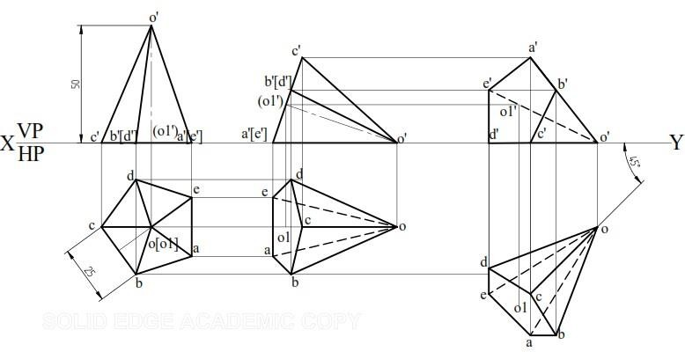
2/D9. A hexagonal pyramid 25mm sides of base and 50mm axis length rests on HP on one of its edges of the base, which is inclined to VP at 30º. Draw the projections of the pyramid when the axis is inclined to HP at 40º.
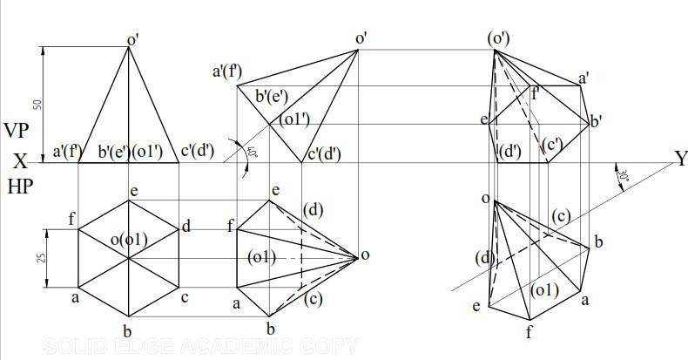

DRAWING NO. 10

CUBE & TETRAHEDRON:
1/D10. Draw the projections of a cube (hexahedron) of 25mm long edges resting on one of its corners on HP such that one of its solid diagonals is perpendicular to VP.
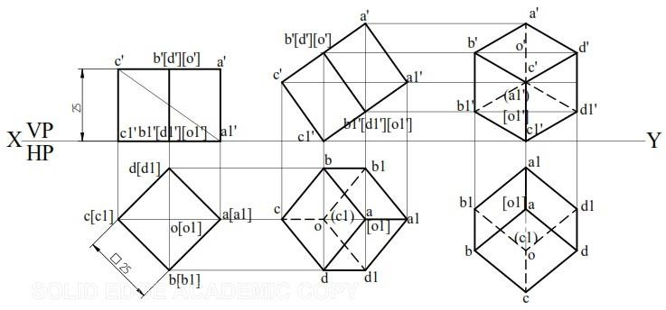
2/D10. A tetrahedron of 55mm sides rests on one of its corners such that the edge containing that corner is inclined to HP at 50º and VP at 30º. Draw the projections.
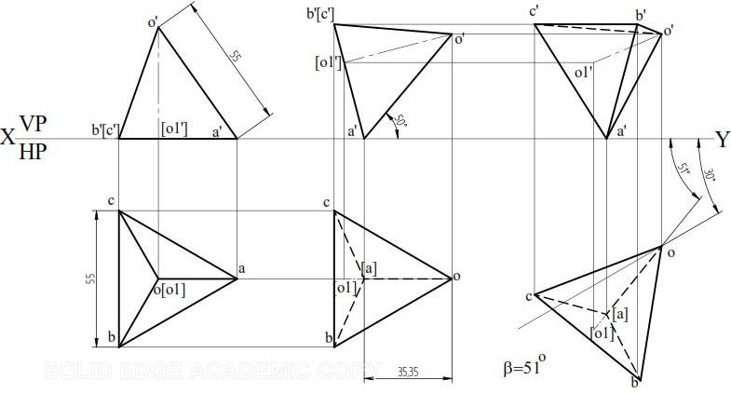

DRAWING NO. 11

ISOMETRICPROJECTION

1/D11. A rectangular prism-A of sides of base 75mm x 30mm and height 15mm rests with its base on HP. Another rectangular prism-B of sides of base 45 mm × 15mm and height 75 mm rests centrally over the prism-A. Draw the isometric projection of the combination of the prisms.
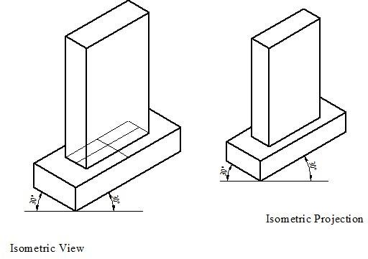

2/D11. A regular pentagonal prism of base edge 30mm and axis 30 mm is mounted centrally over a cylinder block of 80mm diameter and 25mm thick. Draw the isometric projection of the combined solids.

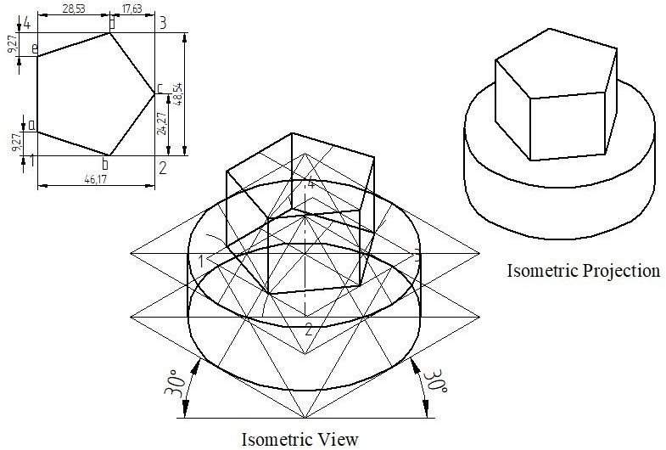

3/D11. A hemisphere of 60mm diameter with its flat circular face at the top is placed centrally on the top flat end of another hemisphere of diameter 80mm. Draw the isometric projection of the arrangement.

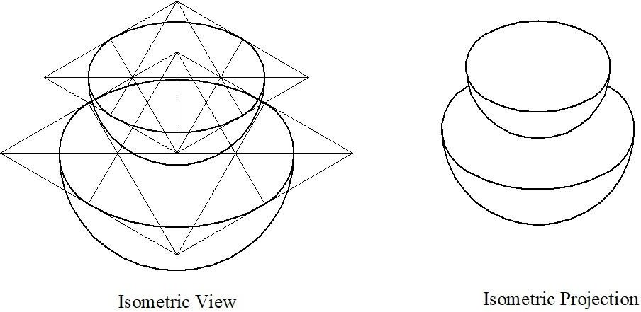
4/D11. A sphere of diameter 40mm rests centrally on the top smaller end of a frustum of a hexagonal pyramid. The frustum of the pyramid has 25mm sides at the top, 40mm sides at the base and is 60mm high. Draw the isometric projection of the combination of the solids.
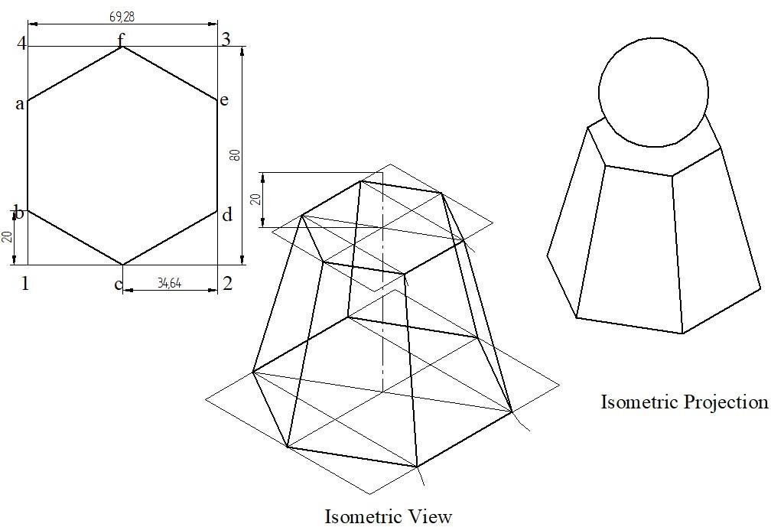

DRAWING NO. 12

CONVERSION OF GIVEN ISOMETRIC/ PICTORIAL VIEWS TO ORTHOGRAPHIC VIEWS:

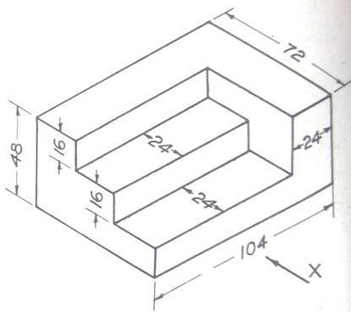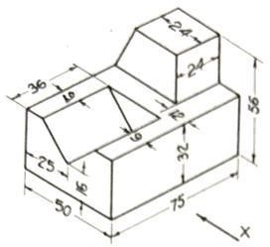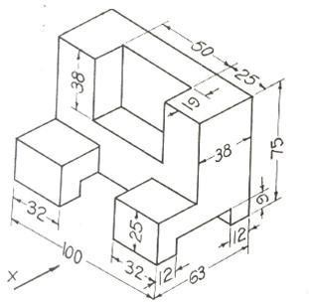
1/D12
2/D12 (D)
3/D12

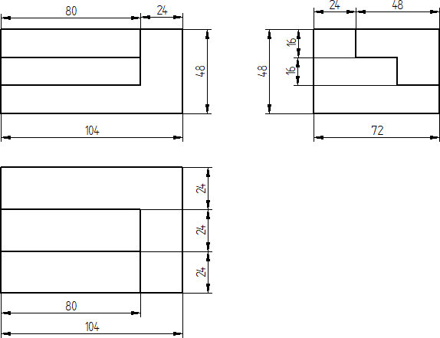

2/D12
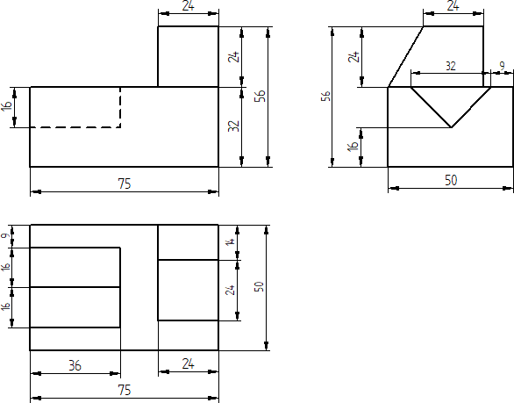

3/D12
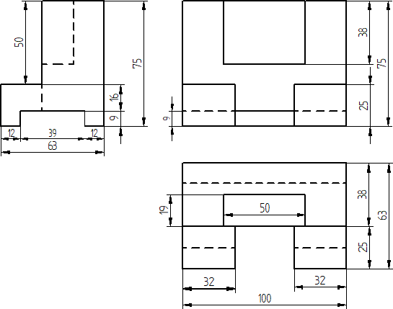

DRAWING NO. 13

DEVELOPMENT OF LATERAL SURFACES OF SOLIDS
PARALLEL LINE DEVELOPMENT:
1/D13. Develop the lateral surfaces of the truncated portion of a vertical square prism 30 mm sides and 60 mm high placed with one of its front rectangular faces leaning to the right at an angle of 30˚ to VP. The truncated surface is at 60˚ to the axis of the prism at its mid-height.

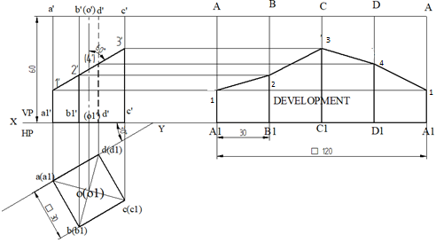
2/D13. Develop the truncated portion of the lateral faces of pentagonal prism 20 mm side of base and 50 mm high stands vertically with one of its rectangular faces parallel to VP and nearer to it so as to produce a one- piece development. The truncated face of the truncated prism is inclined at 30˚ to its axis and passes through the right extreme corners of the top face of the prism.
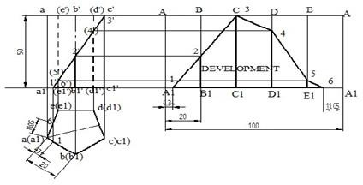

DRAWING NO. 14
RADIAL LINE DEVELOPMENT:
1/D14. Draw the development of part B of the pyramid as shown in Fig.1.
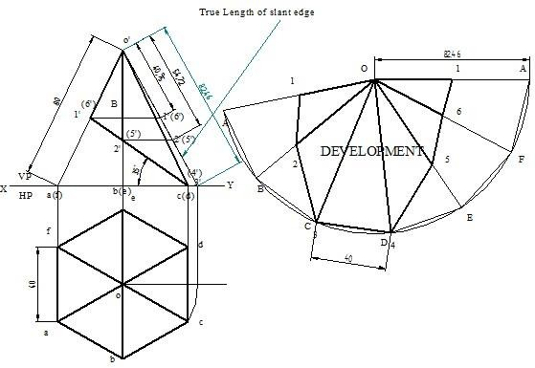

2/D14. A pentagonal pyramid of 30 mm edge of base and 60mm high rest vertically with one of its base edges parallel to VP and nearer to it. It is cut
e la

as shown in Fig.2. Draw the development of th portion of the pyramid.
O teral surfaces of the lower

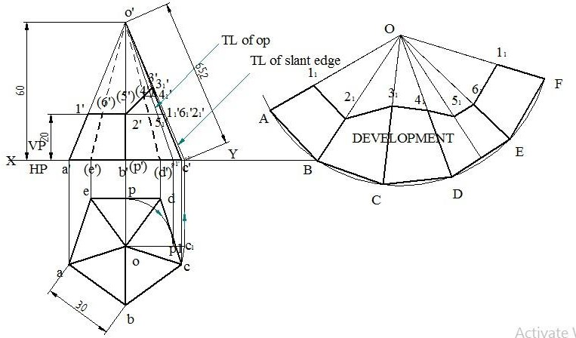

DRAWING NO.15
FRUSTUM, FUNNEL& TRAY:
1/D15. A frustum of a square pyramid has its base 40mm side, top 20 mm side and height 50mm. Draw the development of its lateral surface.
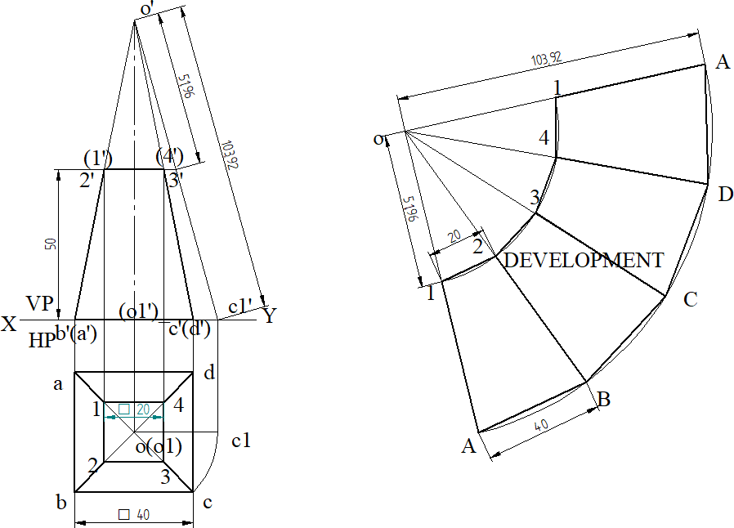

2/D15. A funnel is to be made of sheet metal. The funnel tapers from 60 mm diameter to 30 mm diameter to a height of 25 mm and then forms a cylinder 30 mm diameter. The bottom of the funnel is bevelled off to a plane inclined at 45˚ to the axis. Draw the development of the funnel.

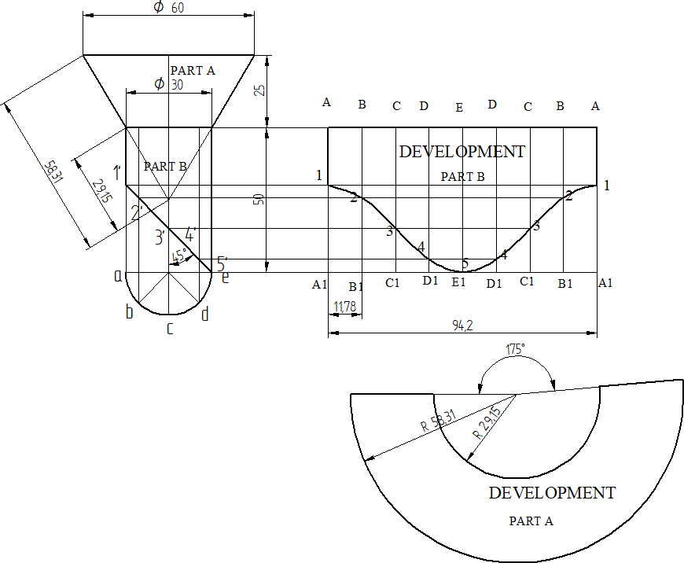

Note:

θ = 360* (r/R)
Where r = Radius of base circle
R= Length of generator/slant length

θ = 360* (30/58.31)
= 185.21 ˚

Circumference =πD= π*30=94.24mm

3/D15.Draw the development of the tray using the following orthographic projection
